Lab1 - Properties of LDR

Yuwei ZHAO, Haohao QI, Yilin ZHANG
March 24, 2025

Abstract

Introduction
This laboratory investigation systematically characterizes the optoelectronic properties of light-dependent resistors (LDRs) through four complementary experimental approaches. The first two

Experiment 1: Investigating the "Light Intensity-Resistance" Changes of LDR under Different Light Conditions with Ground and Power Supply Connections
This experiment investigates the relationship between light intensity and electrical response in light-dependent resistor (LDR) circuits. By constructing two distinct configurations – a ground-connected LDR voltage divider and a supply-connected fixed resistor voltage divider – we characterize how varying illumination levels affect output signals.
Key measurements reveal an inverse relationship: when the LDR forms the lower branch of a voltage divider (connected to ground), its resistance decreases with increasing light intensity. Conversely, when the LDR serves as the upper branch (connected to power supply), the fixed resistor's voltage increases under identical illumination conditions.
These opposing trends demonstrate how component placement in voltage divider networks fundamentally determines a circuit's response to environmental stimuli.

Experiment 2: Plotting the "Light Intensity-Resistance" Changes of LDR under Different Light Intensities
As the incident light intensity increases, the resistance of the LDR decreases; conversely, as the incident light intensity decreases, the resistance of the LDR increases.

Experiment 3: Comparison of the Change Range When LDR is Connected in Series with Different Voltage Divider Resistors
When the LDR is connected in series with a 1kΩ resistor, the change range from weak light to strong light is the largest.

Experiment 4: Investigating the Resistance Difference Between Two LDRs Under Identical Light Conditions
Under the same light conditions, the resistance difference between the two LDRs exceeds 200Ω.

Theory and Technical Background
LDRs’ register changing theory originally comes from semiconductor material. Those chemical material such as cadmium sulfide (CdS) offers election-hole pairs under light. Finally, the increasement of carrier concentration leads to higher electrical conductivity. This property turns out to be a negative correlation between light and resistance. The relationship between them is not linear. Usually satisfies the formula (1). That is, a photoresistor is a semiconductor element based on the internal photoelectric effect, and its resistance value depends on the incident light intensity. As the incident light intensity increases, the resistance value of the photoresistor decreases, and as the incident light decreases, the resistance value of the photoresistor increases. Additionally, dark and bright light turns to totally different trends, with high resistance (up to 1.5 MΩ) in dark conditions opposing to a much lower resistive (small as 1KΩ or less).
 | $R∝E^{-γ}$, where $γ$ is material constant. | （1）

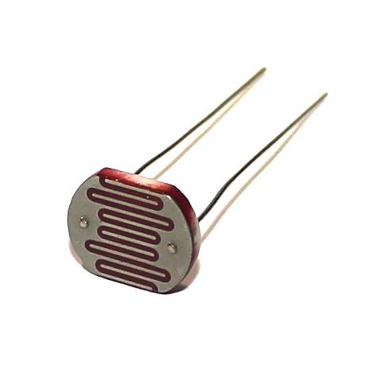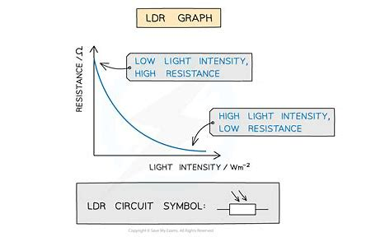
      - Photoresistors and their “Light Intensity-Resistance” curves

Method:
Symbol | Description
ADC | Analog-to-Digital Conversion
IDE | Integrated Development Environment
LDR | Light-Dependent Resistor

Key words：sixth-order polynomial fitting，ADC，control variable

Experiment 1: Investigating the "Resistance-Time" Changes of LDR under Different Light Conditions with Ground and Power Supply Connections
This experiment can be further divided into two sub-experiments: LDR1 & LDR2 both connected to ground, and LDR1 &LDR2 both connected to the power supply. （Fixed resistor resistance value: 1 kΩ）
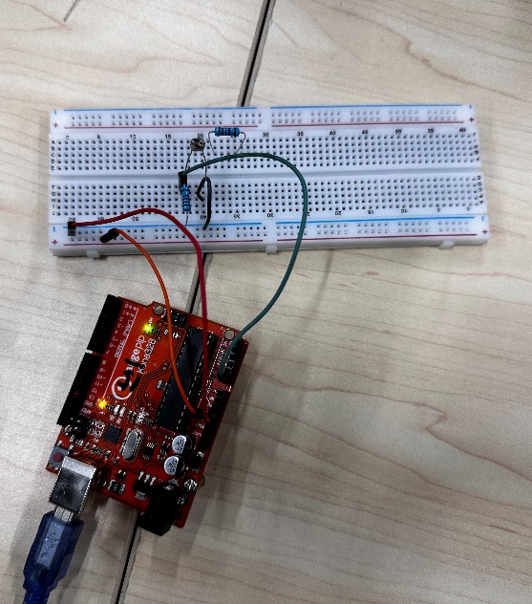
      - Grounding
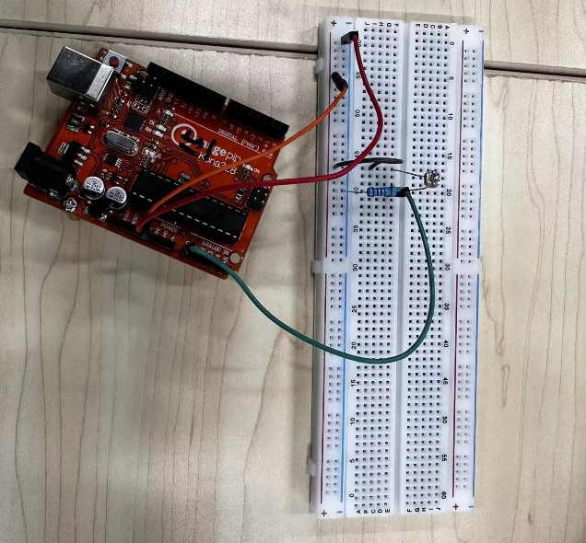
      - Power supply

The program is written using Arduino IDE to obtain the voltage values from the analog pins A0 and A1, and convert them to digital values through ADC. The principle is as follows：
 | 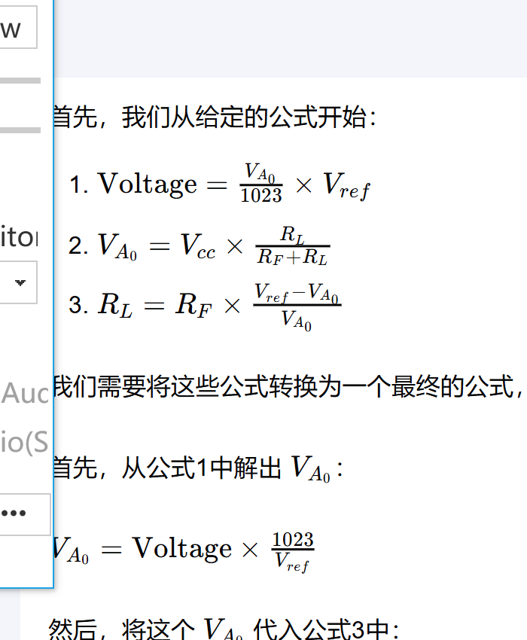 | （1）

（2）

（3）

Finally, get the corresponding sensorValue1 and sensorValue2 from the IDE's Serial Monitor. Then, using a sixth-order polynomial fitting, 300 points are inserted between the two data points to obtain a smooth curve. The drawing of the image in the following experiments will use the same method, so we will not repeat it.

Experiment 2: Plotting the "Resistance-Time" Changes of LDR under Different Light Intensities
This experiment can be further turned into a sub-experiments: LDR1 connected to the ground. (Fixed resistor resistance value: 1 kΩ)

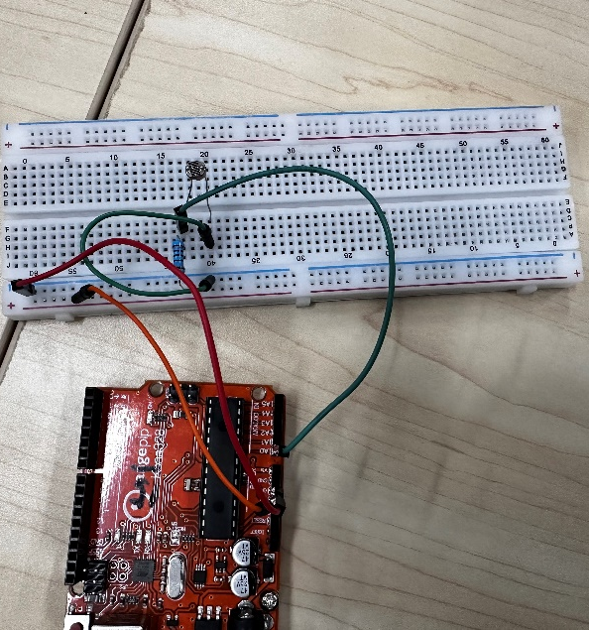
      - Grounding
The program is written using Arduino IDE to obtain the voltage value from analog pin A0 and convert it to a digital value through ADC. The corresponding sensor Value is obtained through the Serial Monitor in the IDE.

Experiment 3: Comparison of the Change Range When LDR is Connected in Series with Different Voltage Divider Resistors
- Voltage divider resistance of 270Ω
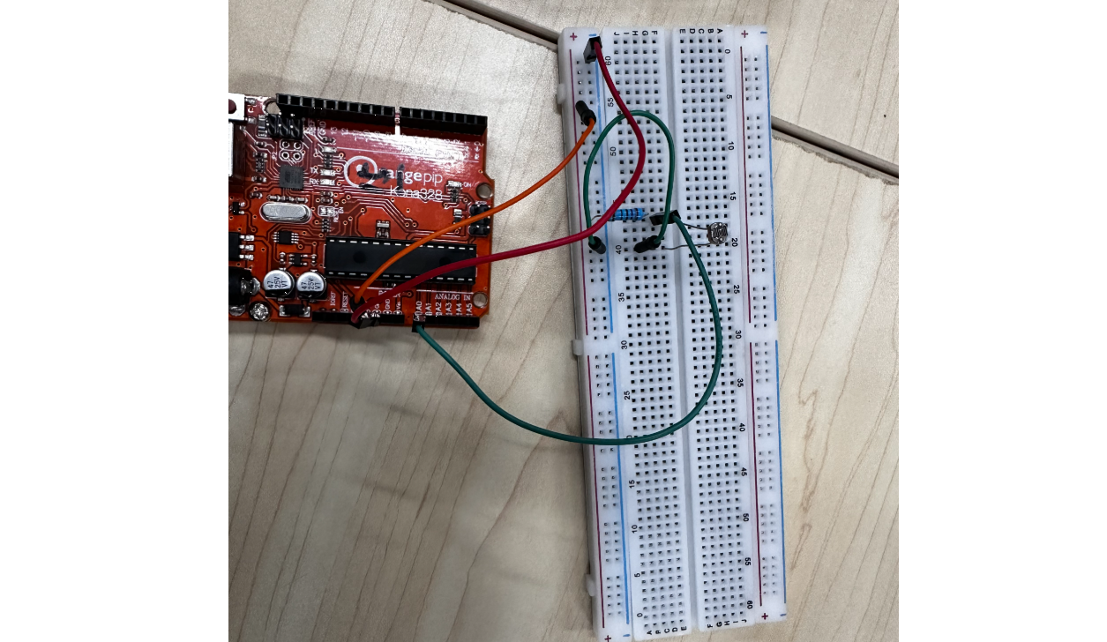
      - 270Ω grounding
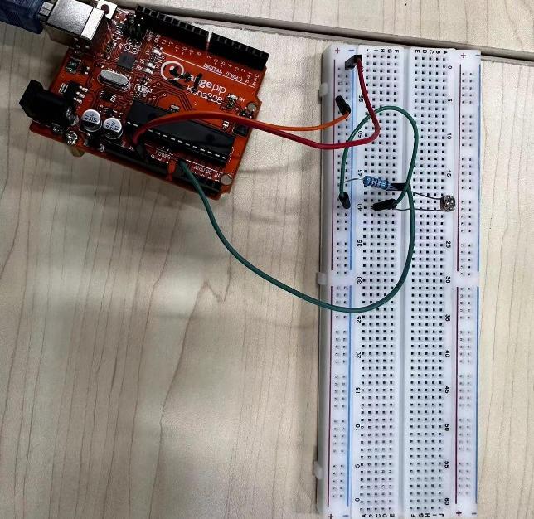
- Voltage divider resistance of 1kΩ
      - 1kΩ grounding
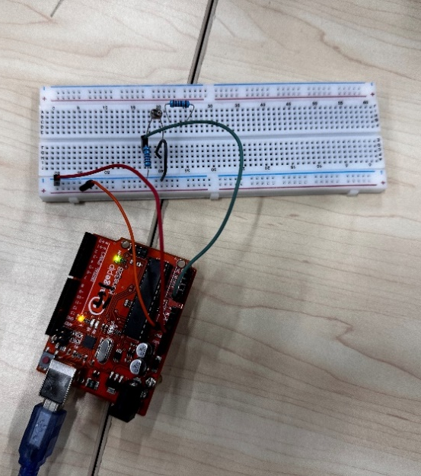
- Voltage divider resistance of 10kΩ：
      - 10kΩ grounding
After obtaining the value of the voltage on the analog pin A0 after ADC, the polar differences are calculated and compared.

Experiment 4: Investigating the Resistance Difference Between Two LDRs Under Identical Light Conditions
This experiment can be further divided into two sub-experiments: LDR1 &amp; LDR2 both connected to ground, and LDR1 &amp; LDR2 both connected to the power supply.
LDR1 and LDR2 are placed in separate circuits with a controlled variable, keeping the voltage and the voltage divider resistors consistent.
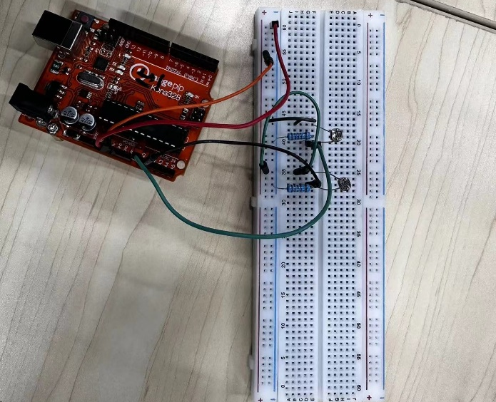
      - Both power supply
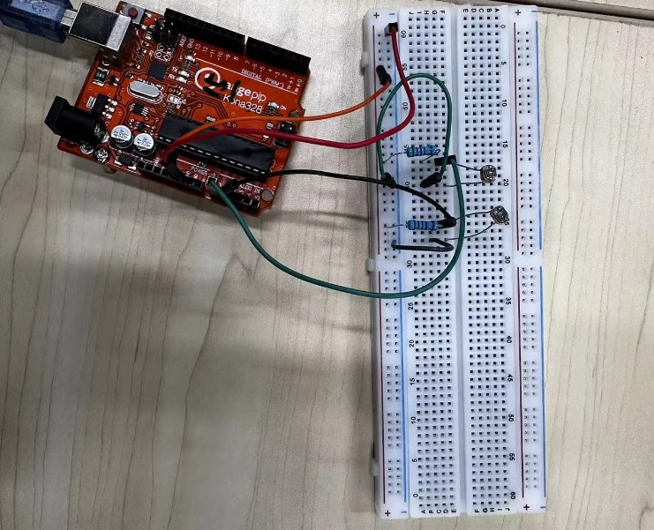
      - Both grounding

Result

Experiment 1
With fixed resistor resistance value 1 kΩ, the corresponding sensorValue is obtained from the IDE's Serial Monitor as follows.
When LDR is grounded, the light goes from strong to weak:
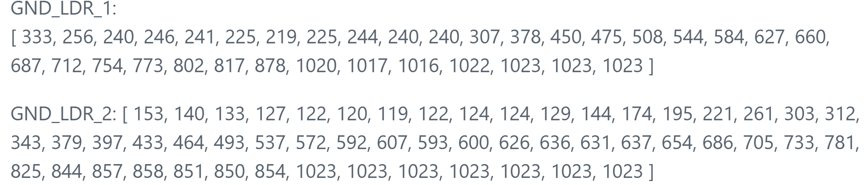

When the LDR is connected to power, the light goes from weak to strong:
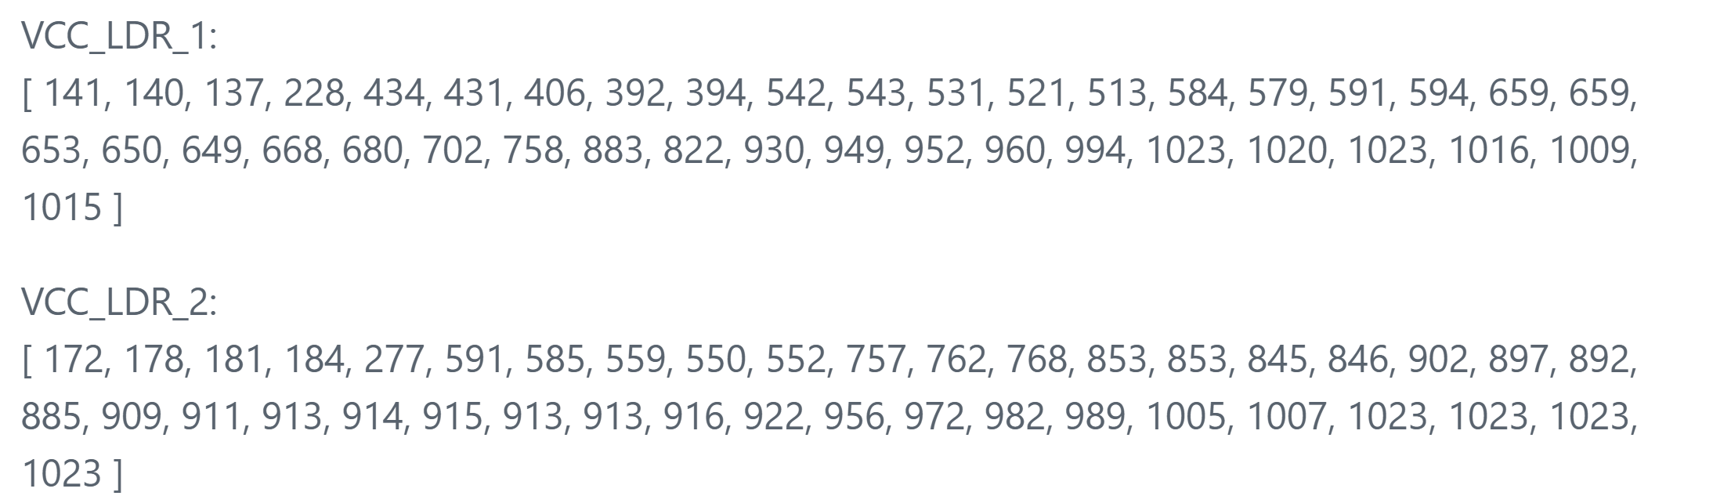
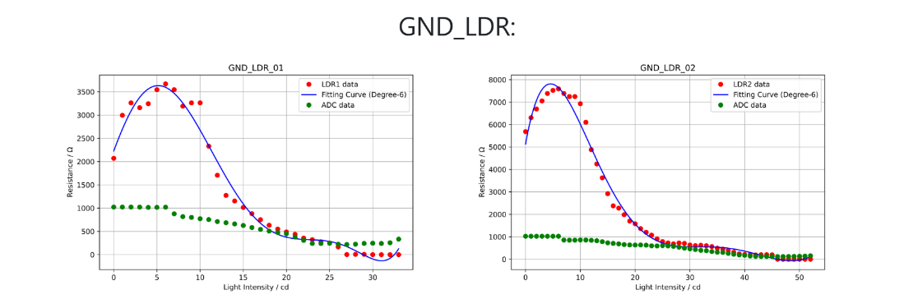
The plotted curves are as follows:
      - LDR1&LDR2 Resistance- Light Intensity Curve at Ground Level
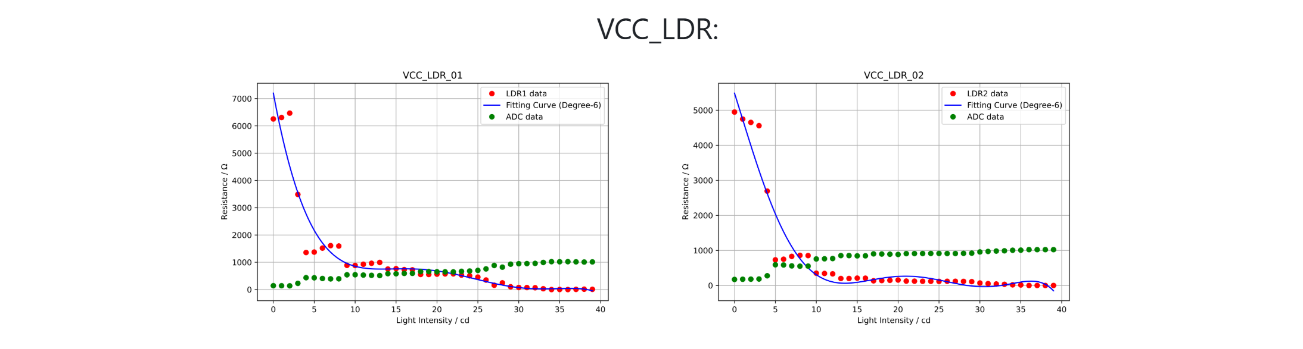
      - LDR1&LDR2 Resistance- Light intensity curve at power supply
Through experimental data and images, we demonstrate that in both cases of LDR connected to power and ground. When connected to ground, the voltage drop across the light-dependent resistor (LDR) is measured. As the light intensity increases, the voltage drop across the LDR decreases from weak light to strong light. When connected to the power supply, the voltage drop across the resistor is measured. As the light intensity increases, the voltage drop across the resistor increases from weak light to strong light.

Experiment 2
With fixed resistor resistance value 1 kΩ and LDR1, the corresponding sensor value is obtained through the IDE's serial monitor as follows:
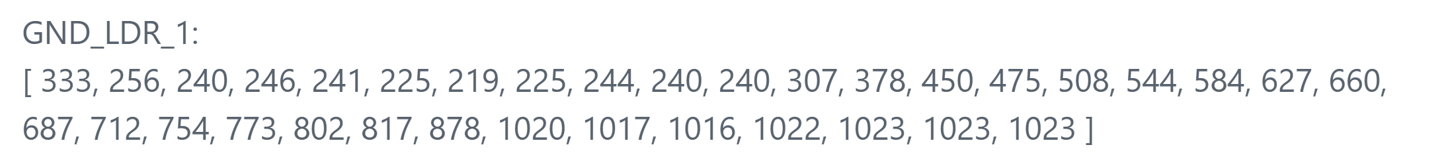
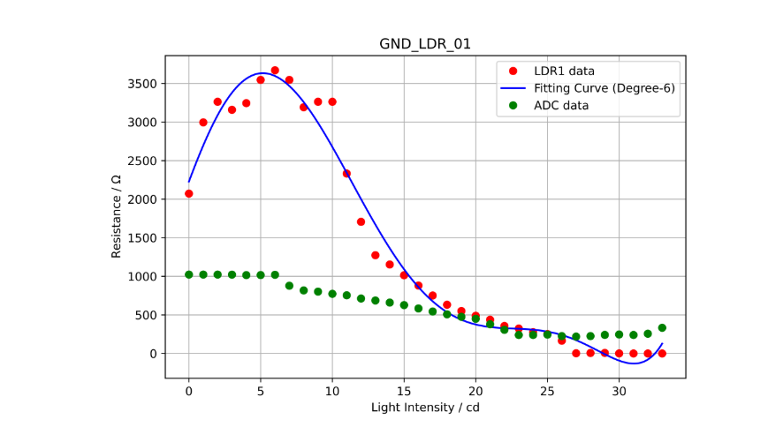
The plotted curves are as follows:

      - LDR1 Resistance- Light Intensity Curve at Ground Level
It can be illustrated from the experimental data and images that the resistance value of the LDR decreases with increasing light, it should be noted that the experimental image does not strictly follow the light from if to strong, the image initially appears to be rising.
The reason for the rise will be explained later.

Experiment 3
- Measured data and curve when the voltage divider resistor is 270Ω shows as follow:
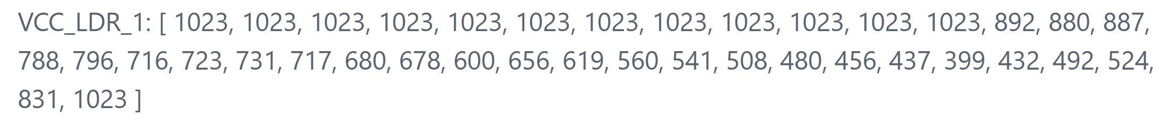
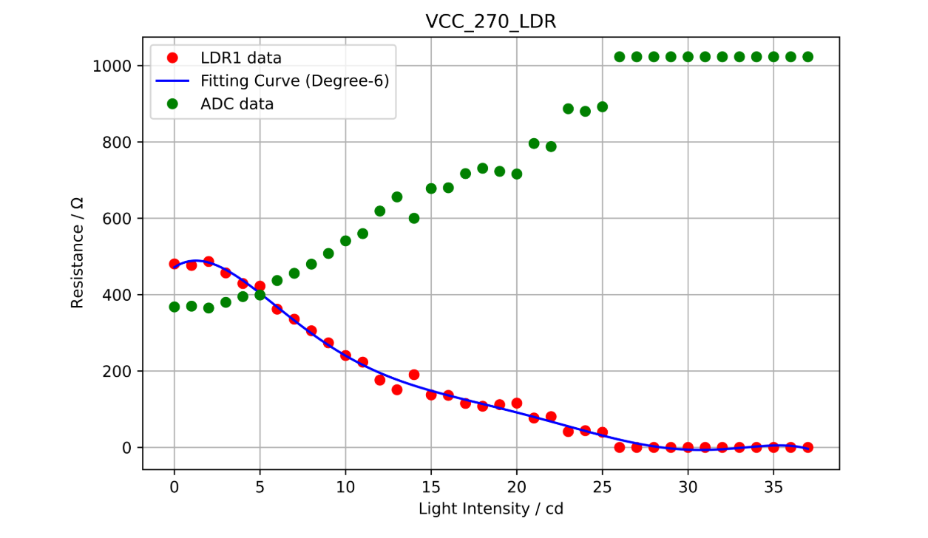
      - LDR1 with 270Ω Resistance- Light Intensity Curve at Ground Level

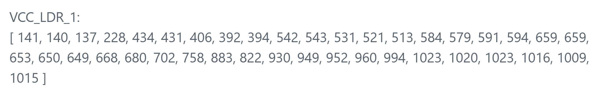
- Measured data and curve when the voltage divider resistor is 1kΩ shows as follow:

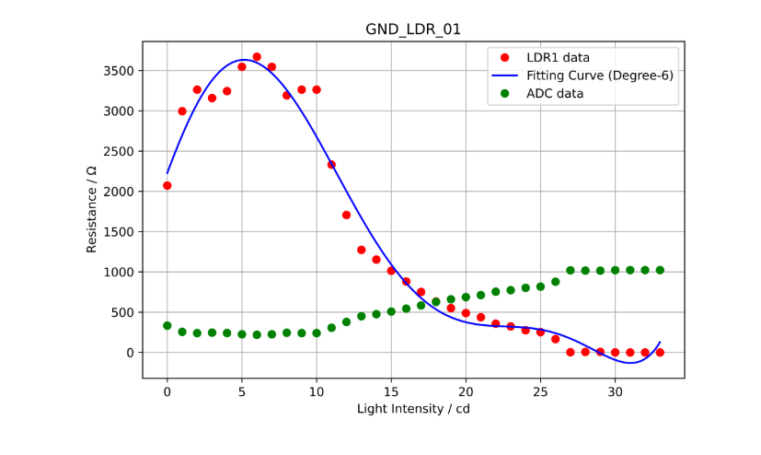
      - LDR1 with 1kΩ Resistance- Light Intensity Curve at Ground Level

- Measured data and curve when the voltage divider resistor is 10kΩ shows as follow:
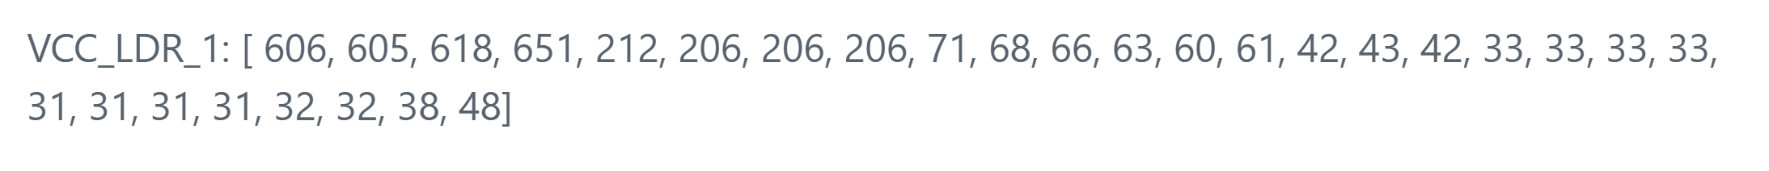
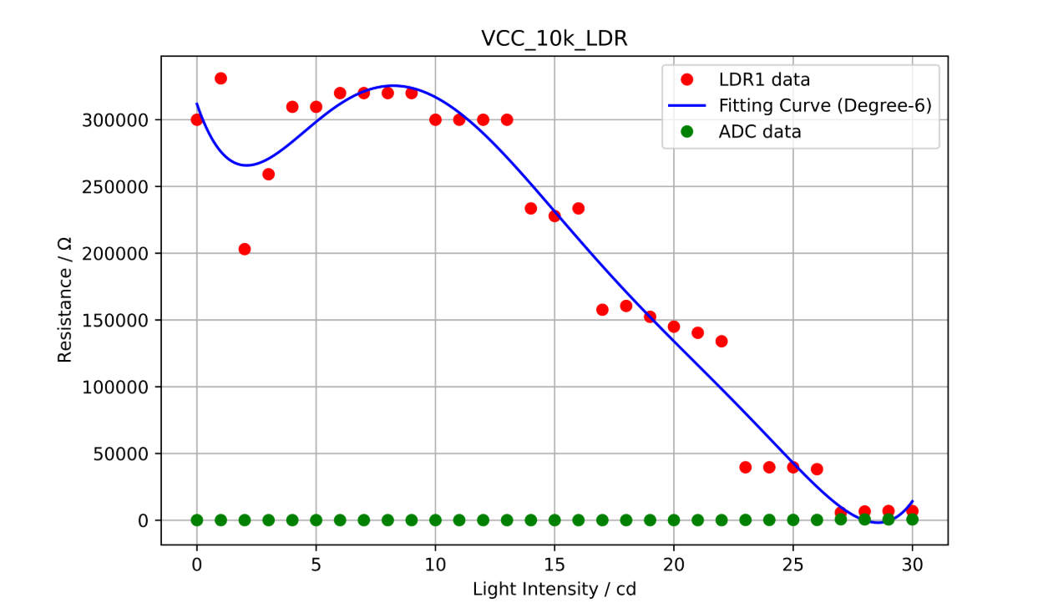
      - LDR1 with 10kΩ Resistance- Light Intensity Curve at Ground Level

        - The polar differences of different resistance
Resistance | Polar difference
270Ω | 624
1kΩ | 690
10kΩ | 558
By calculating the polarity difference, we find that 1kΩ has the largest polarity difference. That is to say when 1kΩ is used as a voltage divider resistor，the change range from weak light to strong light is the largest.

Experiment 4
When the light is swept from LDR1 to LDR2, the following data is obtained: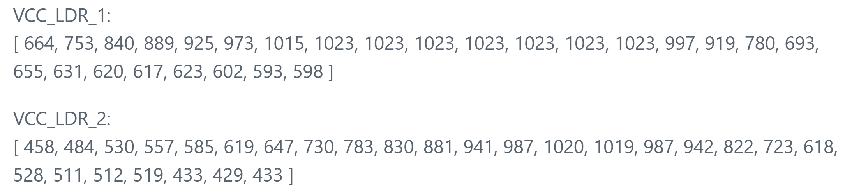

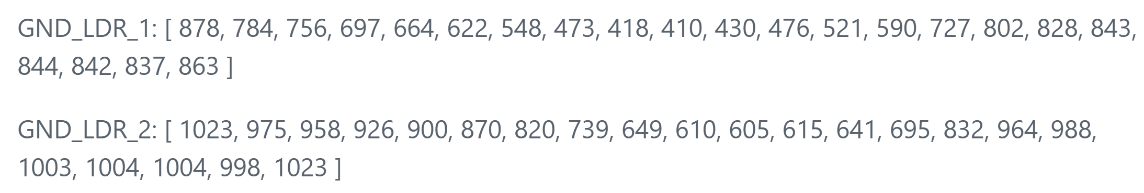
When the light is swept from LDR2 to LDR1, the following data is obtained:
The experimentally obtained curves are as follows:

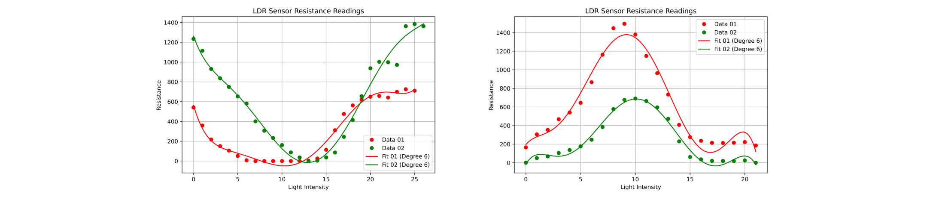
      - light swept from LDR2 to LDR1&from LDR1 to LDR2
Through the data and curves we can see that in the same lighting environment, the resistance values of LDR1 and LDR2 maintain a relatively large difference, a value that can exceed a maximum of 200 Ω under polarized light conditions.

Conclusion
- Conclusion and Summary:
This experiment consists of four sub-experiments:
1) It verified the characteristic of the LDR, where its resistance decreases as the light intensity increases.
2) It was determined that, for our LDR, using a 1kΩ series resistor in the voltage divider results in the maximum range of resistance variation from darkness to bright light. This finding will assist in selecting an appropriate voltage divider resistor in subsequent experiments to enhance the sensitivity of the LDR's response.
3) It was observed that the resistance difference between two LDRs under different lighting conditions in the same light environment is significant, providing a reliable basis for using the resistance difference of the two LDRs as a judgment criterion in future experiments.
- Limitations of the experiment:
1) The experimental environment could not fully eliminate the influence of the laboratory lighting, which led to the observed curve exhibiting an initial increase followed by a decrease.
2) Achieving a smooth variation in light intensity proved challenging, resulting in abrupt changes in the data and the curve.

Appendix
- The code used for plotting is as follows:
import numpy as np
import mlx.core as mx
import matplotlib.pyplot as plt

R_Fixed = 1000.0
Vref = 5.0

adc_values_01 = np.array([
172, 178, 181, 184, 277, 591, 585, 559, 550, 552, 757, 762, 768, 853,
853, 845, 846, 902, 897, 892, 885, 909, 911, 913, 914, 915, 913, 913,
916, 922, 956, 972, 982, 989, 1005, 1007, 1023, 1023, 1023, 1023
])

Vout = adc_values_01 / 1023.0 * Vref

R_LDR = R_Fixed * ((Vref - Vout) / Vout)

x_values = mx.arange(stop=len(adc_values_01))

poly_degree = 6
poly_coeffs_01 = np.polyfit(x_values, R_LDR, poly_degree)
poly_func_01 = np.poly1d(poly_coeffs_01)

x_dense = mx.linspace(start=x_values.min(), stop=x_values.max(), num=300)
y_dense = poly_func_01(x_dense)

plt.figure(figsize=(8, 5))
plt.plot(x_values, R_LDR, 'ro', label="LDR2 data")
plt.plot(x_dense, y_dense, 'b-', label=f"Fitting Curve (Degree-{poly_degree})")
plt.plot(x_values, adc_values_01, 'go', label="ADC data")

plt.xlabel("Light Intensity / cd")
plt.ylabel(r"Resistance / $\Omega$")
plt.title("VCC_LDR_02")
plt.grid(True)
plt.legend()

plt.savefig("./Photos/Chart/VCC_LDR_02.png", dpi=1200)

plt.show()

- The code used to get the ADC value is as follows:
void setup() {
// put your setup code here, to run once:
Serial.begin(9600);
}

void loop() {
// put your main code here, to run repeatedly:
int sensorValue_A0 = analogRead(A0);

Serial.print("Sensor Value of A0 = ");
Serial.println(sensorValue_A0);
Serial.println();

delay(1);
delay(1000);
}

